1. Instructions: <https://github.com/suzam26/cc4-project1-python27>
2. Fork this repo if you like. The important files are:
   1. [app.py](https://github.com/suzam26/cc4-project1-python27/blob/master/app.py) - start a service that listens on port 8080 forever
   2. [requirements.txt](https://github.com/suzam26/cc4-project1-python27/blob/master/requirements.txt) - list of Python dependencies
3. Open the OpenShift console: <https://console.preview.openshift.com/console/>
4. Create a new Project

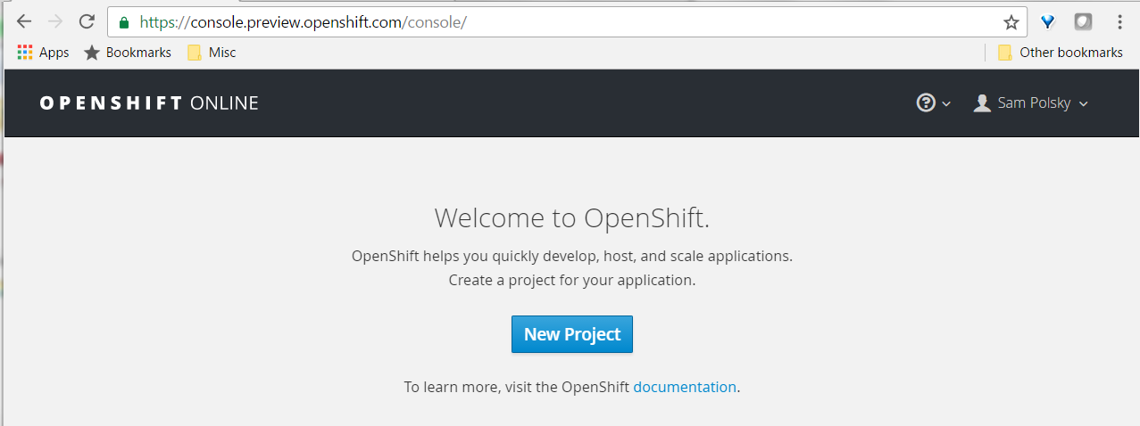

1. Add new Python2.7 component with your github repo's url
2. In github: Add OpenShift's webhook url to your github repo

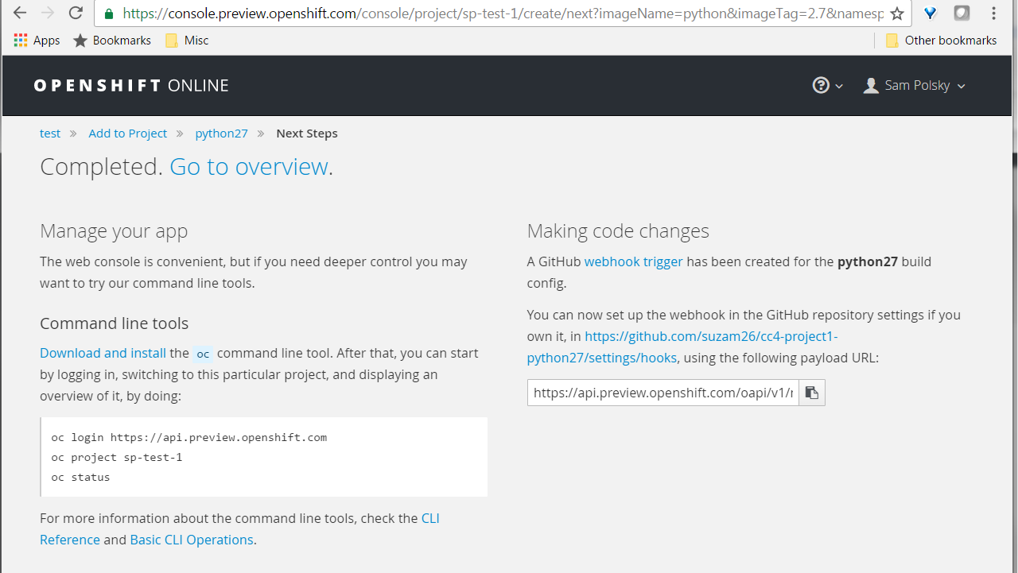

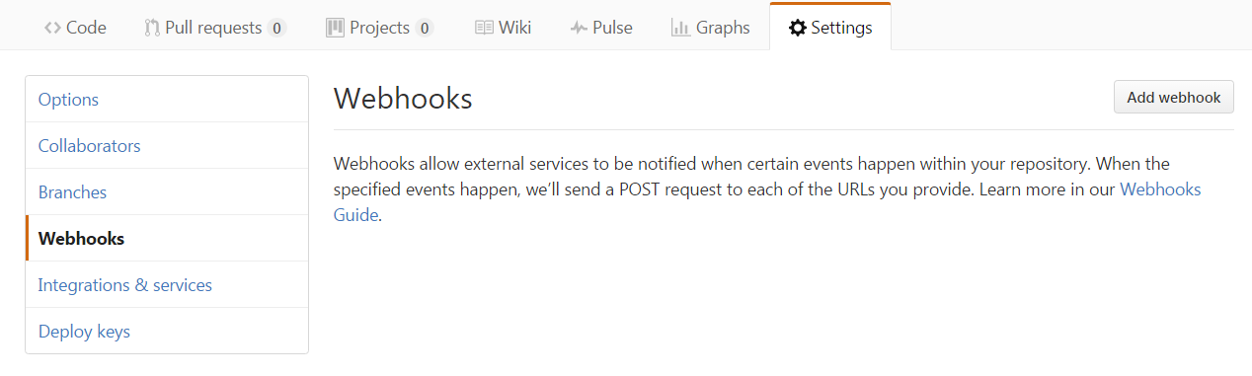

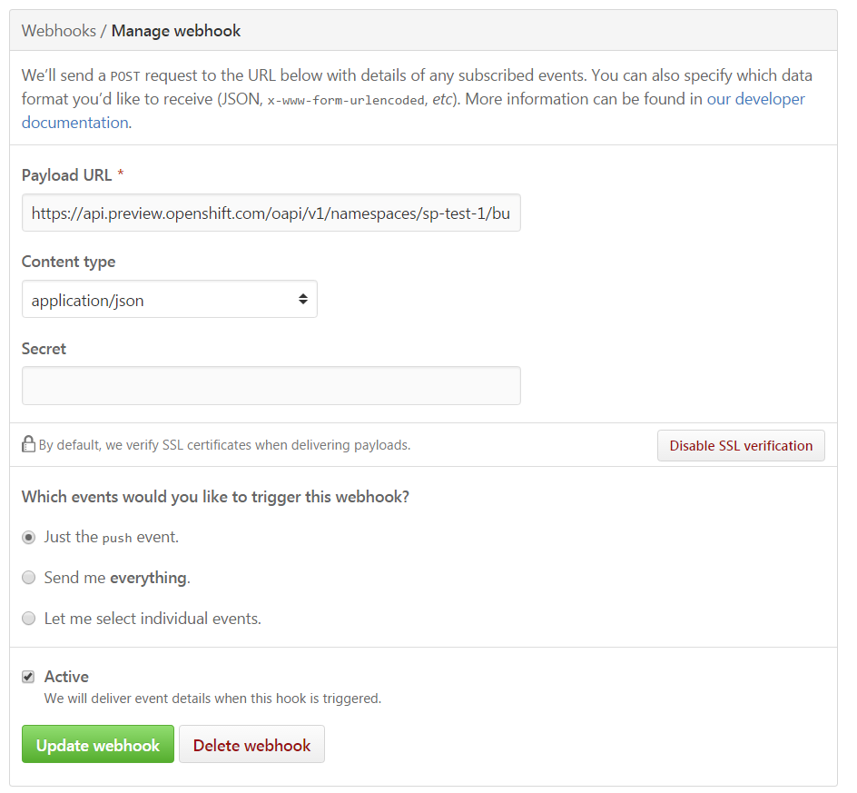

1. Back to the OpenShift console, wait for your project to rebuild, then click the link in the upper right corner of the screen. That should be your application printing "Hello World". Congratulations!
2. Clone your repo locally, change app.py and push the changes. OpenShift will automatically rebuild it using the webhook you added earlier.

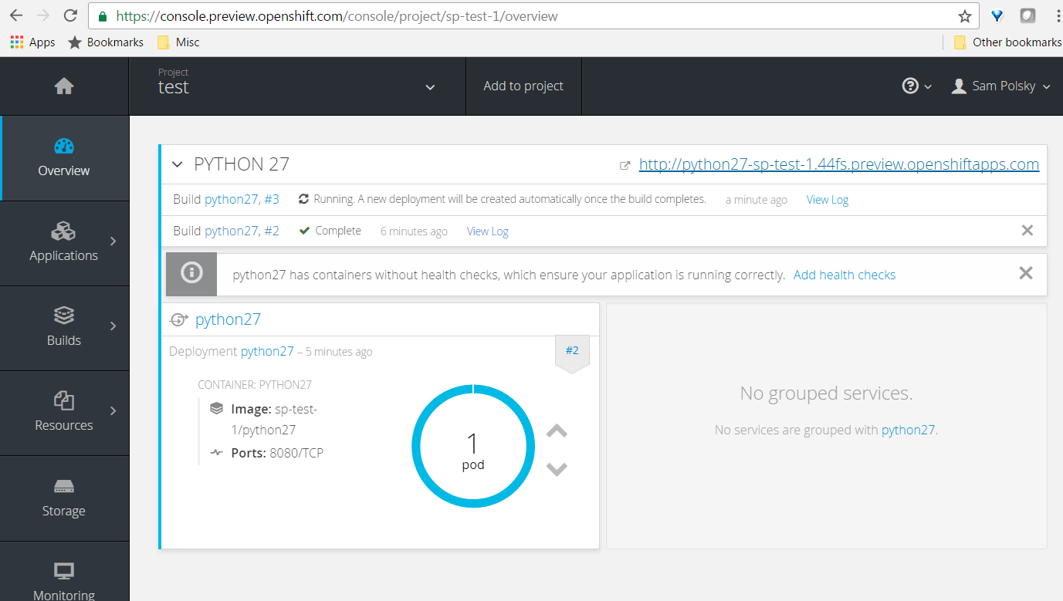

1. Congrats! You’re done

There's a command-line interface too, at <https://console.preview.openshift.com/console/command-line>. You can get a token to log in at <https://api.preview.openshift.com/oauth/token/request>